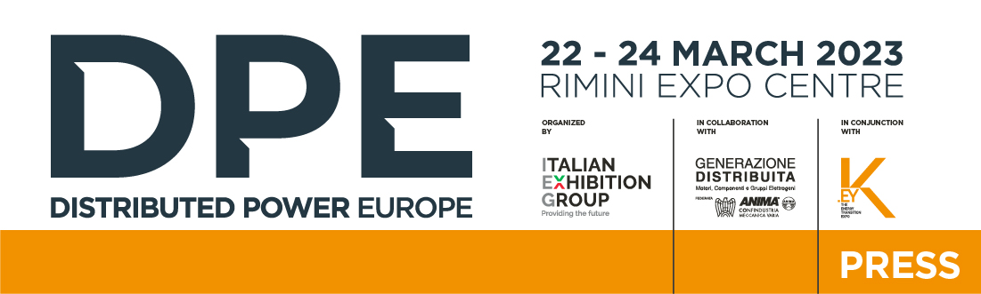

press release

IEG: THE FIRST EDITION OF DPE – DISTRIBUTED POWER EUROPE
THE EUROPEAN EXHIBITION OF ELECTRICAL POWER SYSTEMS GETS UNDERWAY

The event, organised by Italian Exhibition Group in collaboration with the Distributed Generation Association - Engines, Components, Generators centralised into ANIMA Confindustria, will take place from 22nd to 24th March at Rimini Expo Centre, in conjunction with K.EY - The Energy Transition Expo

Rimini, 21st March 2023 – The first edition of DPE - Distributed Power Europe, the European event dedicated to the entire electrical generation, distribution, safety and automation ecosystem, organised by Italian Exhibition Group in collaboration with the Distributed Generation Association - Engines, Components, Generators centralised into ANIMA Confindustria, is about to get underway.

DPE – The European Exhibition of Electrical Power Systems is scheduled to take place from 22nd to 24th March at Rimini Expo Centre, in conjunction with K.EY - The Energy Transition Expo, IEG's reference event for energy transition and renewables in Italy, Africa and the Mediterranean Basin.

The event aims at the distributed generation sector with an offer of solutions and technologies from the systems and components for the generation and distribution of electricity industry, hitherto absent in Italy. The strong synergy and integration with the industrial sectors in attendance at K.EY - The Energy Transition Expo will further enhance all the topics related to energy transition and the new structure that the electricity grid is assuming, also through two important scheduled events: Ecological Transition and New EU Targets. The future of the endothermic engine and technological neutrality, organised by IEG and the Distributed Generation Association (23rd March) and Distributed electricity generation: opportunities and regulations, organised by NT24.it (24th March).

Recent international dynamics have given significant impetus to reshoring the sector's production chain, providing an opportunity for Italy and Europe to consolidate its engineering and production leadership role. In this perspective, DPE represents an opportunity for the many Italian and European companies to showcase their excellence.

A zero edition of DPE was already held in November 2019, but now the project has expanded to the entire electricity generation and distribution systems and components industry. Space will therefore not only be given to generators, internal combustion engines, alternators, light towers, static and dynamic UPSs, but also to transformers, conversion systems, cables and distribution systems, static and dynamic power factor correction systems, switchgear, mechanical, electrical and electronic components and all the product categories of the electricity generation and distribution systems and components industry.

A vast and comprehensive offer for designers, installers, distributors, utilities, consulting and engineering companies, O&M, contractors, ESCOs, maintenance and rental companies. A reality in enormous evolution, where innovation and sustainability are increasingly important and where the points of contact with the sectors on show at K.EY are plentiful and clear.

ABOUT DPE - Distributed Power Europe
Event: European Trade Show; Organization: Italian Exhibition Group S.p.A.; Edition: 1st; Dates: 22-24 March 2023; Website: www.dpeurope.it; LinkedIn: https://www.linkedin.com/company/dpe---distributed-power-europe/

PRESS CONTACT ITALIAN EXHIBITION GROUP
head of media & corporate communication: Elisabetta Vitali; press office manager: Marco Forcellini; international press office manager: Silvia Giorgi; media@iegexpo.it

MEDIA AGENCY: Smartitaly Communications
Sara Scatena, s.scatena@smartitaly.it, mob. +39 338 7836985; Arianna Geli, a.geli@smartitaly.it, mob. +39 347 0917903

This press release contains forecast elements and estimates that reflect the management’s current opinions (“forward-looking statements”), particularly regarding future management performance, realization of investments, cash flow trends and the evolution of the financial structure. For their very nature, forward-looking statements have a component of risk and uncertainty, as they depend on the occurrence of future events. The effective results may differ (even significantly) from those announced, due to numerous factors, including, only by way of example: food service market and tourist flow trends in Italy, gold and jewellery market trends, green economy market trends; the evolution of raw material prices; general macroeconomic conditions; geopolitical factors and evolutions in the legislative framework. Moreover, the information contained in this release, does not claim to be complete, and has not been verified by independent third parties. Forecasts, estimates and objectives contained herein are based on the information available to the Company as at the date of this release.

